**Problem 1:**

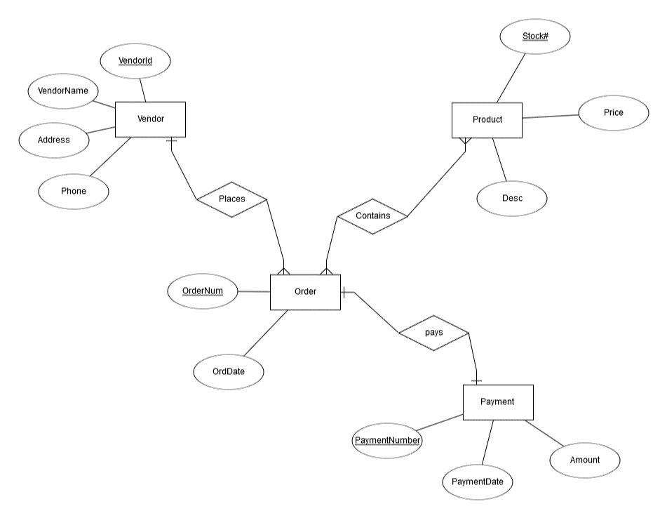

**Table from ERD**

Vendor: VendorId, VendorName, Address, Phone

Product: Stock#, Price, Desc

Order: OrderNum, OrdDate, VendorId (VendorId is foreign key)

Payment: PaymentNumber, PaymentDate, Amount

OrderDetail: OrderNum, Stock# (Both are foreign key)

**Problem 2:**

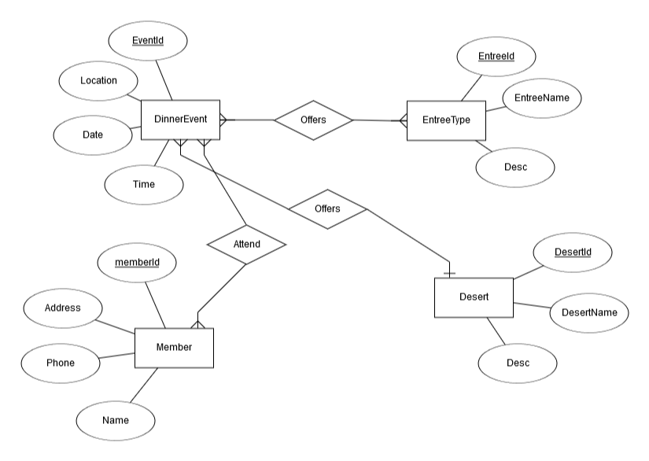

**Tables from ERD:**

Member: memberId, Address, Phone, Name (memberId and EventId are foreign key)

Desert: DesertId, DesertName, Desc

EntreeType: EntreeId, EntreeName, Desc

DinnerEvent: EventId, Location, Date, Time, DessetId (DesertId is foreign key)

EntreeOffers: EventId, EntreeId (Both are foreign key)

MemberAttended: memberId, EventId (memberId and EventId are foreign key)

**Problem 3:**

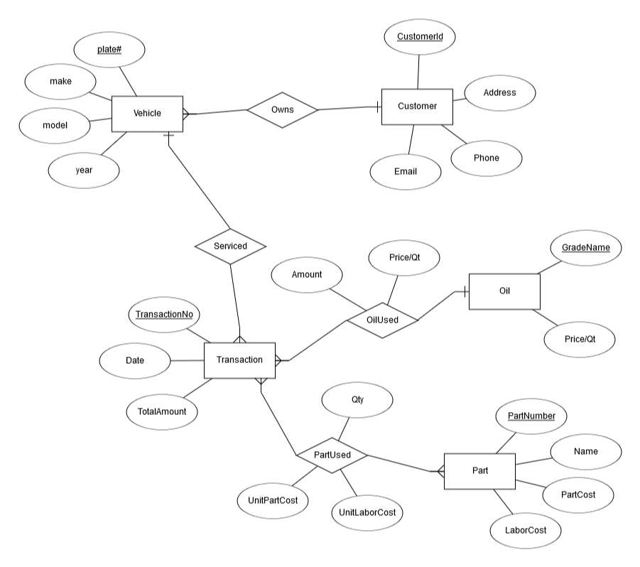

**Tables from ERD:**

Oil: GradeName, Price/Qt

Part: PartNumber, Name, PartCost, LaborCost

Customer: CustomerId, Address, Phone, Email

Vehicle: plate#, make, model, year, customerId (CustomerId is foreign key)

Transaction: TransactionNo, Date, TotalAmount, GradeName, plate#, Price/Qt, Amount (GradeName and plate# are the foreign key)

PartReplaced: TransactionNo, partid, Qty, UnitPartCost, UnitLaborCost

**Problem 7:**

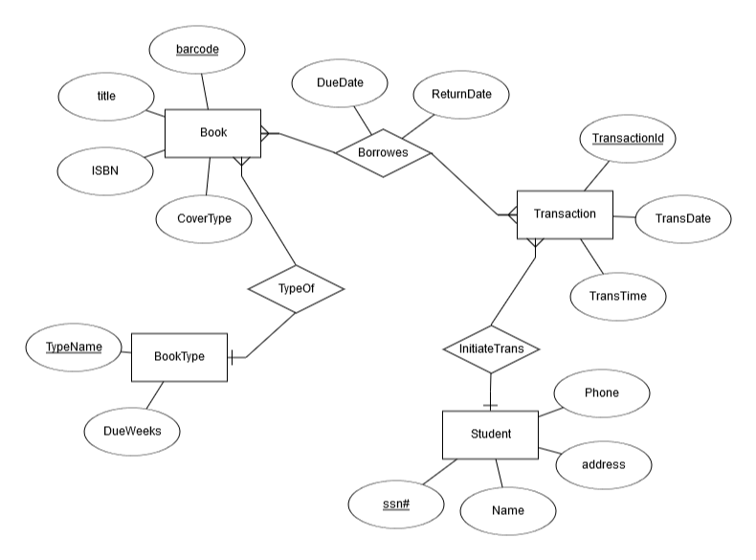

**Tables from ERD**

Student: (ssn#, Name, address, Phone

BookType: TypeName, DueWeeks

Book: barcode, title, ISBN, CoverType, TypeName

Transaction: TransactionId, TransDate, TransTime, ssn#

TransactionDetails: TransactionId, barcode, DueDate, ReturnDate

**Problem 13:**

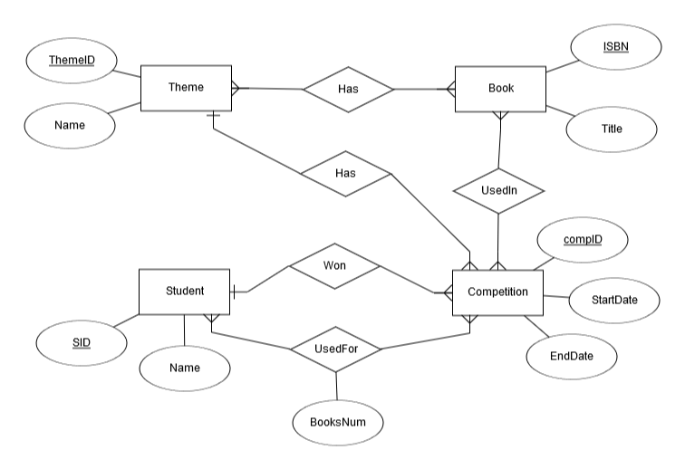

**Tables from ERD:**

Theme: ThemeID, Name

Book: ISBN, Title

Student: SID, Name

Competition: compID, StartDate, EndDate, ThemeId, WinnerId(SID)

ThemeBooks: ThemeID, ISBN

CompetitionBooks: compID, ISBN

Participants: compID, SID, NumberOfBooks